1.Employee

INSERT INTO Employee values(1,'Suresh','Manager','Chennai');

INSERT INTO Employee values(2,'ramesh','Supervisor','Madurai');

INSERT INTO Employee values(3,'Hari','Assisstant','Trichy');

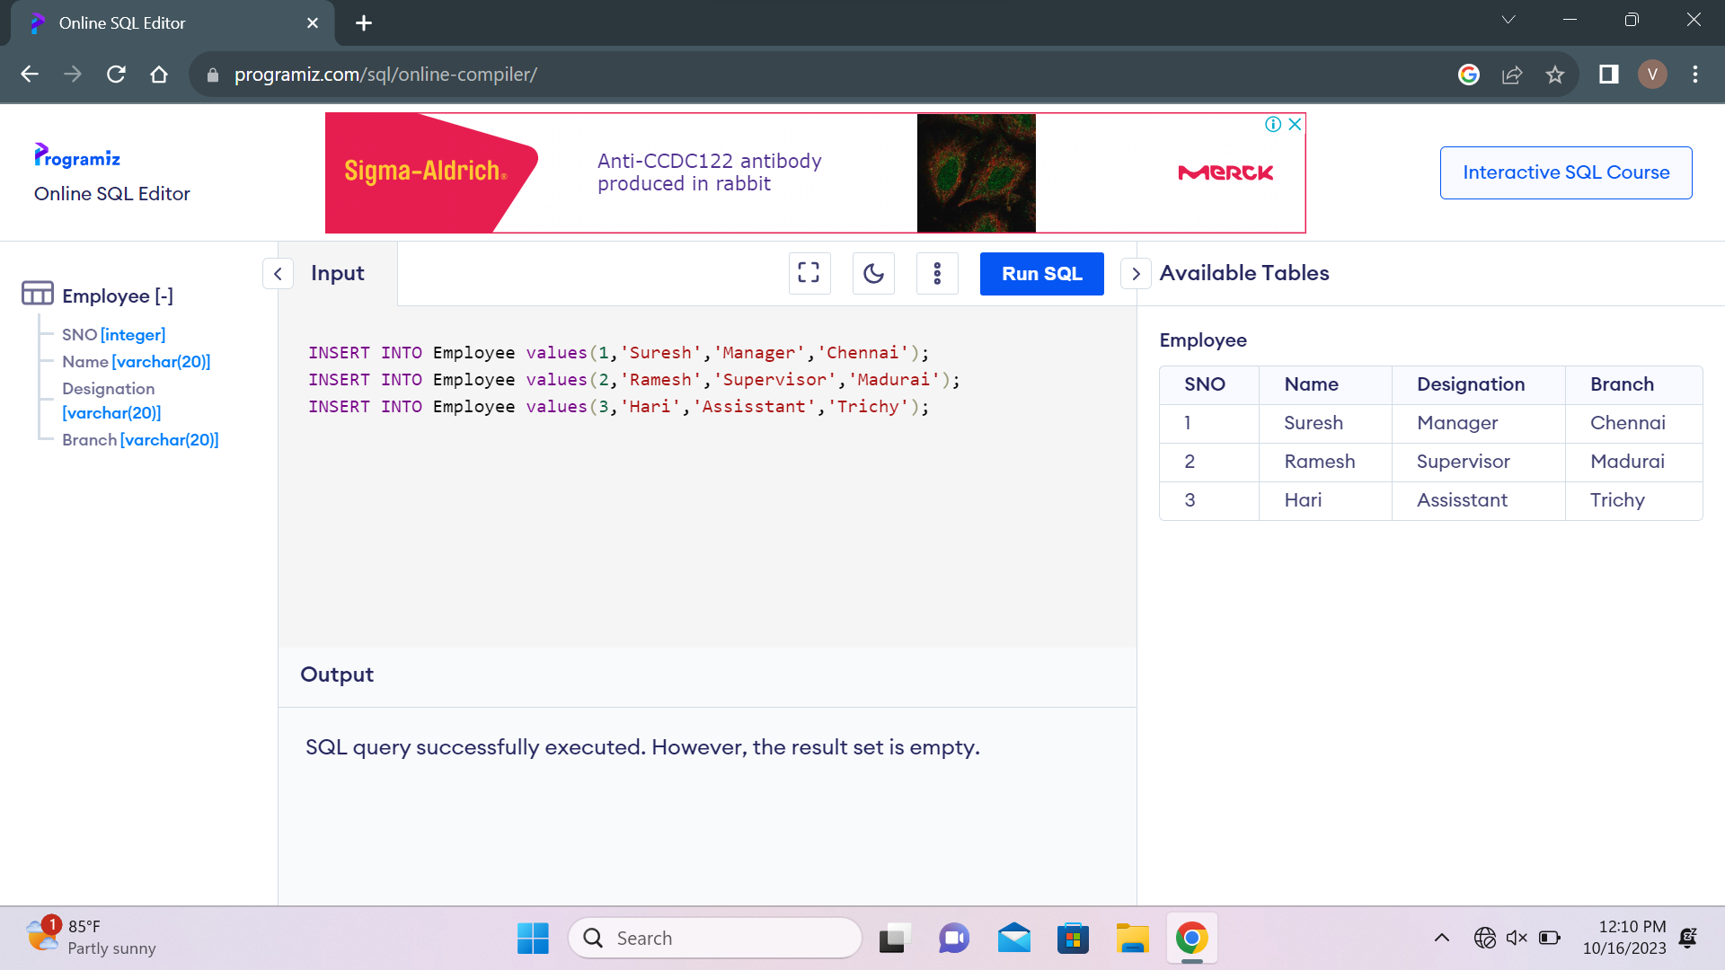

ALTER TABLE Emp

ADD Salary integer(6,2);

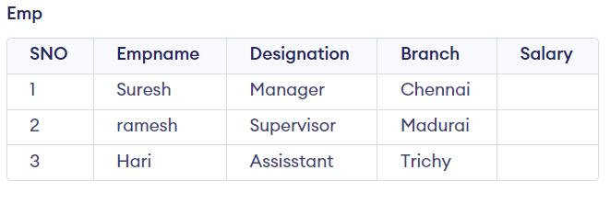

ALTER TABLE Employee

RENAME COLUMN Name TO Empname;



SELECT \*

FROM Employee;



ALTER TABLE Employee

RENAME TO Emp;

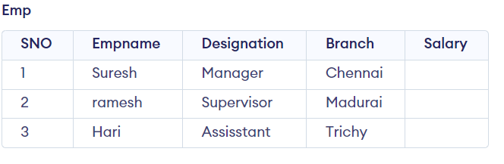

DELETE

FROM Emp

WHERE SNO=2;

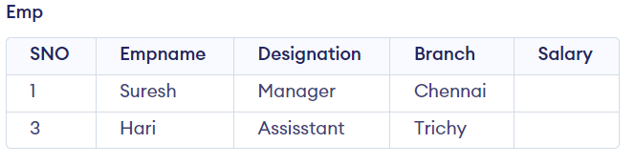

DROP TABLE Emp;



